Registered Firm Contact FAQ
Will RICS notify me of any data discrepancies once my data template has been submitted?
Yes, RICS will always send an email communication to the registered firm contact notifying them of any membership numbers supplied on your data input template which does not match our internal system
Will RICS send communication when my data template is due to be submitted for Round 1 & 2?
Yes, RICS will send communication in August to complete your Round 1 Data Input Template, and Round 2 communication will be sent in January 2025 to complete your data input template for any new starters & also a chance for your firm to claim any refunds for leavers
Where can I find the Terms and Conditions for Corporate Payment Scheme 2025?
Our Terms and Conditions can be found via our main website page for corporate payment – please see link below Corporate Payment Scheme
Will my firm be able to submit changes, once the Round 1 Invoice has been issued?
All corporate firms will have a revision deadline specified when the invoice is sent, during this period (2 weeks prior to your invoice becoming due for payment) your firm is able to send any leavers to be updated on the invoice, and any new additions which need to be added to your Round 1 invoice.
Once your revision deadline has then passed you will need to include any new starters on your Round 2 Data Input Template & claim any refunds for leavers on this requested template sent us in January 2025 as no further revisions will be honoured after this time.
Please note any new starters waiting to be submitted on your Round 2 Data Input Template – may need to be notified to disregard any renewal reminders in the interim of us receiving your Round 2 Data Input Template.
What happens if we have new starters join the firm, after Round 2 has taken place?
The Corporate Team will be able to add any new starters after your Round 2 invoice has been issued to Round 3 which takes place in July 2025 – this round is typically for any upgrade / election charges once your employees pass their RICS assessments, and gain qualification, however, if you have new starters you can notify corporate@rics.org to add to your corporate payment scheme for 2025.
Please note if you add employees to Round 3 RICS will not request a data template – as this round is only used for assessment related fees, therefore if you require to add someone you will be liable for their subscription fees and no removals can take place once added for 2025 please send membership number first name surname to corporate@rics.org
How do I notify RICS of a change in firm contact?
If your registered firm contact provided on your data input template has changed – please forward this notification to corporate@rics.org for us to update our system we will require, their first name, surname & email address / telephone number
Who can I contact the Corporate Team for an urgent enquiry?
We have 2 contact methods for the Corporate Team, we have a dedicated email address which is corproate@rics.org alternatively, you can contact our Corporate Team Monday – Friday 9.00 – 5.00pm on 02475 095359
What is the eligibility to claim a refund for someone we have paid for on the Round 1 invoice?
If you are wishing to gain a refund for an employee who has left your firm, RICS will expect these details to be provided on your Round 2 Data Input Template, we will have a specified tab for any new starters and a tab for any leavers you wish to claim a refund for.
As per our Terms and Conditions for 2025 – if you wish to claim a refund your employee must have left your firms employment prior to the 31st of January their leaver date will need to be specified on your Round 2 Data Input Template – if not provided RICS will reach out to gain this information from you.
Any leavers after the 31st of January 2025 must be recoup via your employee directly as RICS will not issue any refunds for leavers after the 31st of January 2025.
What happens if we provided someone on a data input template who has already paid RICS directly?
RICS has scheduled checks to ensure if an employee has made payment in the interim of issuing your invoice, we will flag this information at the bottom of your cost breakdown tab, so we are not double charging your firm.
What happens if we provide someone on our data input template who is not yet enrolled, or not in membership?
RICS has scheduled checks to ensure if an employee has a valid membership as a candidate – if we can see our system is flagging your employee as not yet enrolled will flag this information at the bottom of your cost breakdown tab.
Further information on enrolling your candidates can be found via our Corporate Enrolment Team – their dedicated email address is corporatenrolments@rics.org
If the employee is showing on our system as being enrolled but not in active membership due to non-payment or a different reason i.e regulation compliance they will need to complete a readmission process which is not billable via the corporate payment scheme due to a separate processes needing to be completed – they can contact readmissions@rics.org or find further information on our readmission process via this link - Readmission to RICS
What will my employees see on their RICS portal view once added to our corporate payment scheme?
When your employees sign into their RICS Portal View – they will see the below wording, confirming your firm will be making payment for their candidate or professional fees for 2025. This will also restrict the system in allowing them to select or make payment through another means.
Please note, your employees will be able to download and see their corporate invoice, however payment is not allowed on the system – once paid the invoice will show as paid on their account.
Point of contact within your firm is also provided, and our main email address for any queries your employees have.
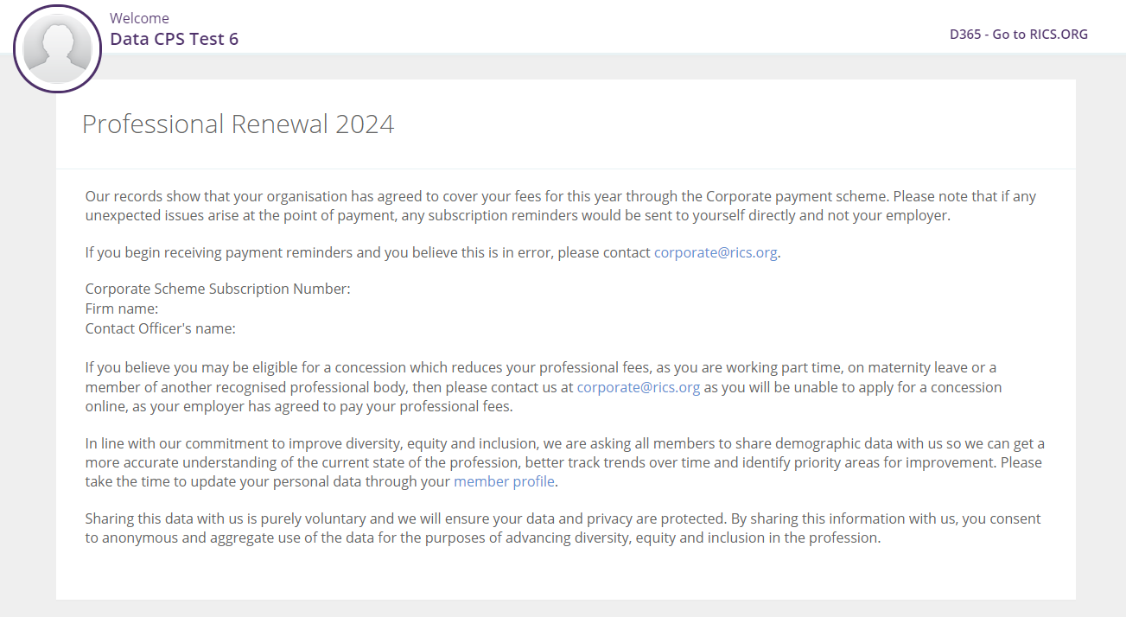
What are RICS membership grades we have?
RICS has many membership grades, this depends on the route of qualification your employees have undertaken or working towards currently. Please see listed below our membership grades
- MRICS
- FRICS
- AssocRICS
- Associate Candidate
- APC Candidate
- Student / non-member records – not yet enrolled with RICS, once enrolment is confirmed they will have a candidate membership grade.

Invoicing Timeline for 2025 & when can I expect my first invoice?
Round One - Data is requested from firms in August and Invoices are sent out no later than November
Round Two - Data is requested from firms in January and Invoices are sent out no later than March.
Round Three - Historic Data is used to establish newly qualified members and the invoice is sent no later than August.

Concessions are my employees able to gain a reduction in fees due to individual circumstances?

Yes, RICS offers concessions for your employee’s individual circumstances which may reduce their fees for 2025 and CPD requirements. We have recently had changes to the concessions which we offer further information can be found via the below link – if your employees require a concession at any stage of the campaign RICS will honour and refund the difference paid by your firm. Typically, this information should be provided to RICS on the data input template which you return. Concessions

RICS Fee structures for 2025?

RICS has recently increased fees further information by region can be found via the below link Professional fees 2025

Where can I send my remittance once payment has been made for allocation of our corporate payment?
All corporate invoices have a CPS reference included, we always urge you to include this reference when a BACS payment is made to ensure our finance department, can identify your payment, and allocate towards your employees RICS records. If you have not included this reference, it may lead us to send chasers to the registered firm contact seeking a payment commitment date – please always ensure your remittance is sent to BACSID@rics.org
What are the payment methods offered as part of the corporate payment scheme?
We only offer 1 payment method currently which is a BACS payment which will need to be made to the specified bank account listed on the PDF invoice issued to your firm.
Are Lionheart donations included in the fee amounts issued to our firm?
LionHeart is an amazing charity which works with our qualified members and candidates of RICS they offer a range of resources and support to your employees. We do not include LionHeart donations within any of your cost breakdowns issued for corporate payment, however if your firm is wishing to donate to LionHeart this can be done via the below link - LionHeart - Donate
What happens if we cannot comply with the payment deadline specified on your invoice due invoice due date?
We issue all our invoice due dates with a 30-day payment term. RICS will expect cleared funds by your invoice due date. Failure to make payment will result in RICS contacting the registered point of contact with the support of our credit control team, to seek a payment commitment date. If unexpected issues arise, please contact corporate@rics.org and supply us with a payment deadline cleared funds will be received to avoid chaser communication from our credit control team.
How to withdraw from the corporate payment scheme?
If your firm is wishing to withdraw from the scheme, please contact corproate@rics.org to update our system, and ensure any pending invoices are cancelled and re-addressed to your employees for payment directly.

