Employee FAQ’s – Corporate Payment Scheme 2025
This FAQ document has been designed to help your employees with general questions regarding the corporate payment scheme.
How do I know if my firm are paying my subscription fees?
When you sign into your RICS Portal the below wording will display – this will confirm that your firm have supplied data to RICS to pay for your subscription fees for that year.
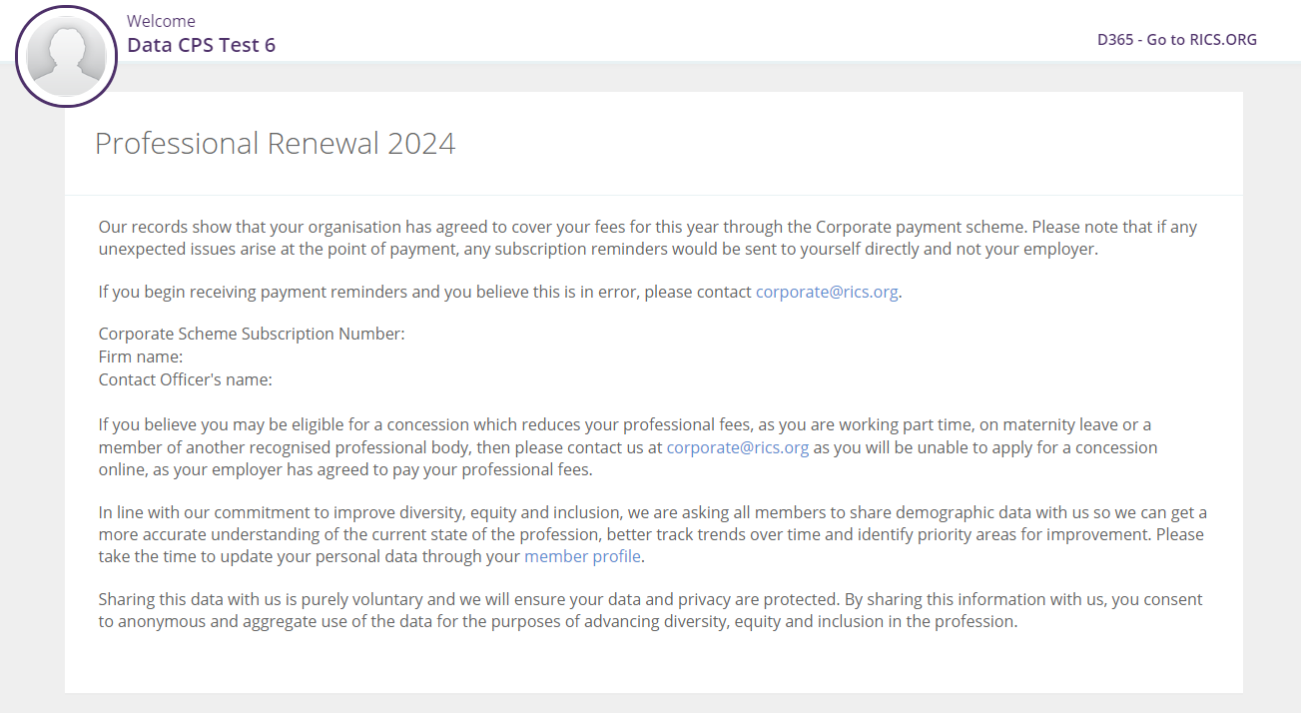

What happens if my firm removes me off the corporate payment scheme?
If you have left you firms employment prior to the 31st of January your firm will notify RICS, in February in which case the Corporate Team will make contact via email to inform you, and relay payment options now available for your 2025 subscription fees.
What happens if I change employer?
If you change employer we suggest you email the details of your new employer to corporate@rics.org if we are still within our invoicing months and your previous firm have requested a refund, we can contact the point of contact within your new firm to add you onto their scheme if registered a part of the corporate payment scheme.
What happens if your circumstances change?
Concessions are available for your firm to apply on behalf of yourself, it is important RICS are made aware of these circumstances, as your employer may need a refund if full feed have been paid, further information on concessionary rates, and reduced CPD hours can be found here: Concessions (rics.org)
We encourage all employees to inform their firm of concessions which are applicable so they can return on their data input templates for 2025.

