Business Lounge - London

A quick guide to the Member Business Lounge
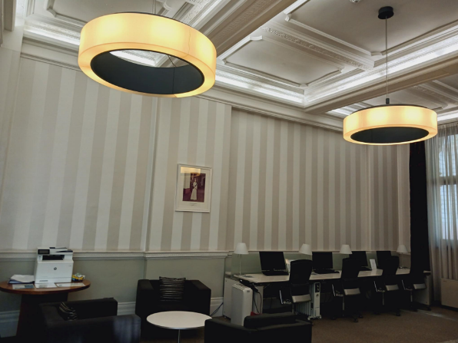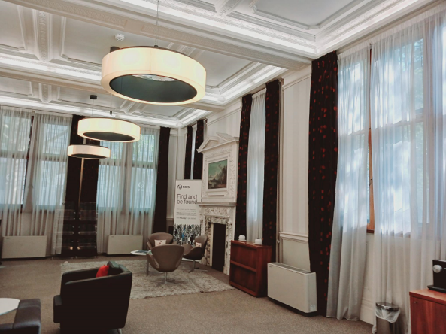
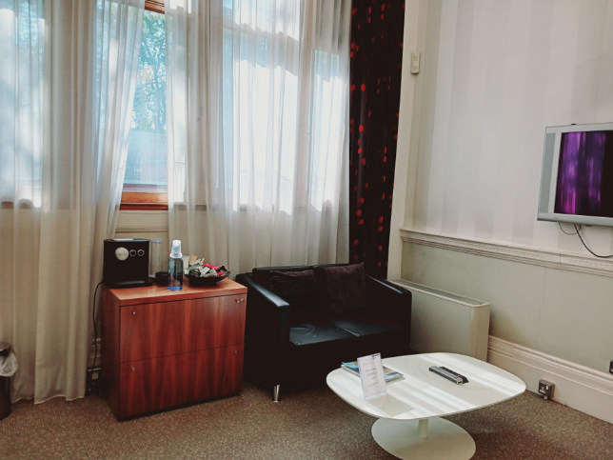
The business lounge is located on the Ground Floor and is open between 0700 and 1930 Monday to Friday. You can access the lounge by speaking to our Reception, showing them your member ID.
We have complimentary beverages and Wi-Fi available for you.

